Name _______________________ Date _______________

capillary action celery cup dish soap
food coloring glue gravity paper towel
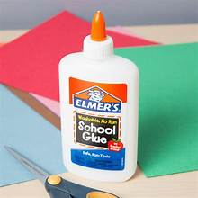
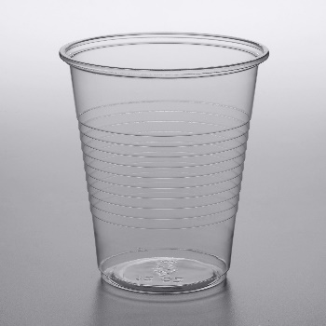

__________________________ __________________________
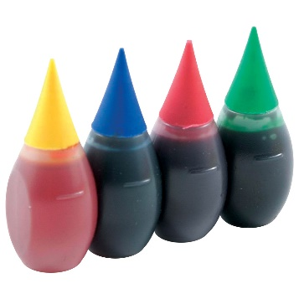
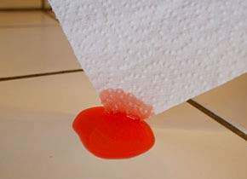

__________________________ __________________________
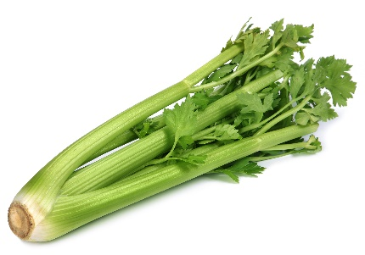
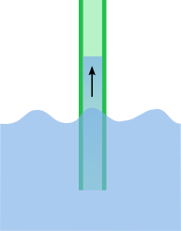

__________________________ __________________________

Name _______________________ Date _______________

capillary action celery cup dish soap
food coloring glue gravity paper towel

__________________________ __________________________
Fill in the blank, then you copy the sentences.

I use a ______________ to drink water. I use ___________________ to clean.

________________________________________ _____________________________________

_____________ causes the apple to fall. I like to eat _____________.

_________________________________________ ____________________________________

_________________________ takes water up to plant leaves.

________________________________________________________________________________

