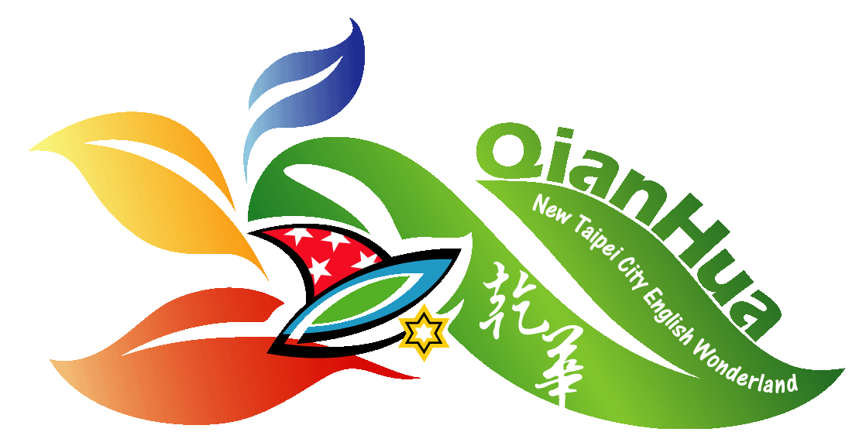
Name ___________________ Date _____________ Team ___________
Walking Water
What are the colors in beakers 1, 3, and 5? ___________ ____________ ___________

What are the new colors in beakers 2 and 4? ____________ ____________

Why did the water travel up? _______________________________________________

Why did the water drop down? ___________________

Milk Art
Name the 3 molecules in milk. 1 ______________, 2. _______________, 3. _______________

What are the 2 charges in the molecules? 1. _________________ 2. __________________

Why was it possible to make colorful swirls on the milk’s surface?

___________________________________________________________________________________

Rainbow Lab
Procedure:
Part 1:

- Label 6 test tubes in order: A, B, C, D, E & F.

- Into test tube A, measure 25 mL of RED liquid.

- Into test tube C, measure 17 mL of YELLOW liquid.

- Into test tube E, measure 21 mL of BLUE liquid.
Part 2:
- From test tube C, measure 4 mL and pour into test tube D.

- From test tube E, measure 7 mL and pour into test tube D. Swirl.

- From test tube E, measure 4 mL and pour into test tube F.

- From test tube A, measure 7 mL and pour into test tube F. Swirl.

- From test tube A, measure 8 mL and pour into test tube B.

- From test tube C, measure 3 mL and pour into test tube B. Swirl.

- Measure the contents of each test tube and record how many mL in each.

Test Tube Results

Test Tube | Color of Liquid | Amount of Liquid (mL)
A
B
C
D
E
F
 | Total liquid Test Tubes | mL

Analysis/Results:

- Name the colors that you created.

B. __________ D. __________ F. __________

- How many mL of liquid were in each test tube?

A. ______ B. ______ C. ______ D. _______ E. _______ F. _______

