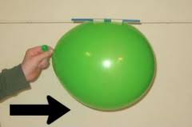
What are 3 reasons some balloon rockets are faster.

- _____________________________________________

- _____________________________________________

- _____________________________________________

