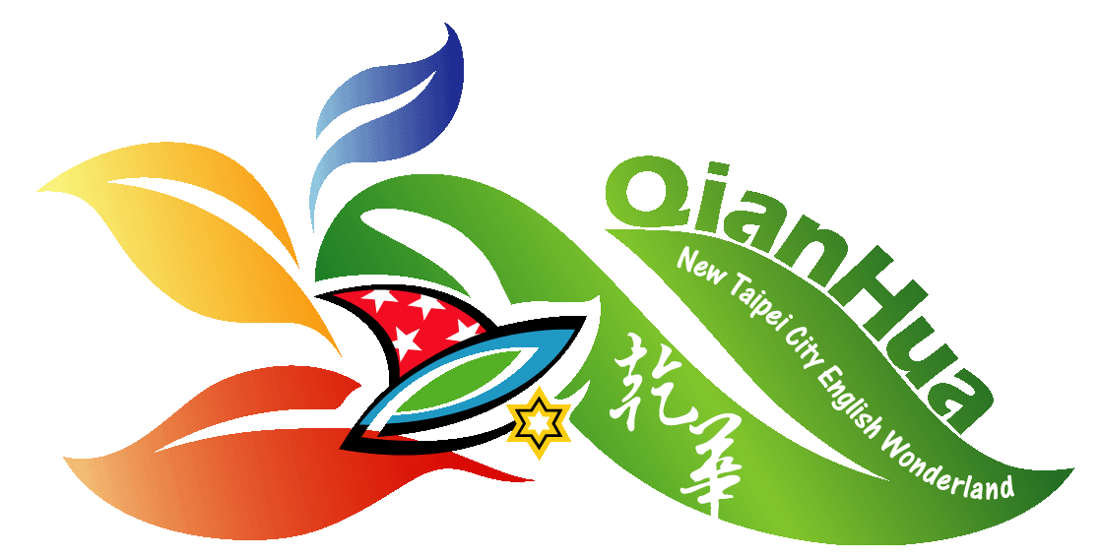
Name _______________________ Date _______________

Objectives:
- to develop skills measuring chemicals with a graduated cylinder.
- to test precision and ability to follow directions.
- to practice lab safety procedures.

Procedure:
Part 1:

- Label 6 test tubes in order: A, B, C, D, E & F.

- Into test tube A, measure 25 mL of RED liquid.

- Into test tube C, measure 17 mL of YELLOW liquid.

- Into test tube E, measure 21 mL of BLUE liquid.

Part 2:
- From test tube C, measure 4 mL and pour into test tube D.

- From test tube E, measure 7 mL and pour into test tube D. Swirl.

- From test tube E, measure 4 mL and pour into test tube F.

- From test tube A, measure 7 mL and pour into test tube F. Swirl.

- From test tube A, measure 8 mL and pour into test tube B.

- From test tube C, measure 3 mL and pour into test tube B. Swirl.

- Save your results and check with your teacher.

- Measure the contents of each test tube and record how many mL in each test tube.

Name ___________________ Date _______

Data:
Table 1: Test Tube Results

Test Tube | Color of Liquid | Amount of Liquid (mL)
A
B
C
D
E
F
 | Total liquid Test Tubes A-F | mL

Analysis/Results:

- Name the colors that you created. B. __________ D. __________ F. __________

- How many mL of liquid were in each test tube at the start of this lab? _____________

- What would have happened if your measurements were not correct?

_______________________________________________________________________

- How many mL of liquid did you have at the end of the lab? ________________

- How many should you have? ________________

- What are some reasons why you may have more or less than when you started?

________________________________________________________________________

