**Bullies are angry.**

**Bullies are sad.**

**Bullies don’t like themselves.**

**Bullies bully**

**in the washroom.**

**Bullies bully**

**on the bus.**

**Bullies bully**

**on the playground.**

**Bullies bully**

**in the cafeteria.**

**You can**

**tell them to stop.**

**You can**

**tell a friend.**

**You can**

**tell a teacher.**

**You can**

**tell a parent.**

**Why ?**

**Why do bullies bully?**

**Why ?**

**Why do bullies bully?**

**Why ?**

**Why do bullies bully?**

**Where?**

**Where do bullies bully?**

**Where?**

**Where do bullies bully?**

**Where?**

**Where do bullies bully?**

**Where?**

**Where do bullies bully?**

**What?**

**What can you do?**

**What?**

**What can you do?**

**What?**

**What can you do?**

**What?**

**What can you do?**

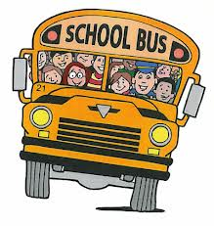

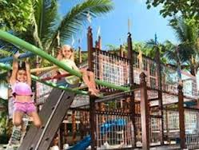

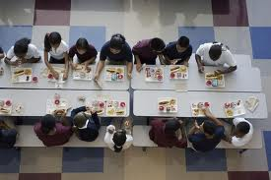





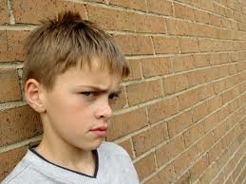

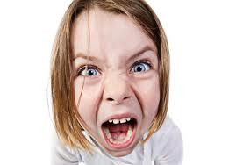

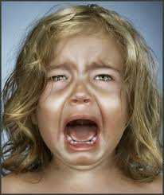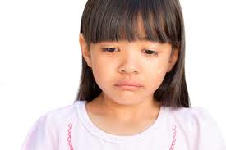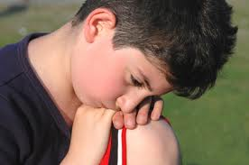

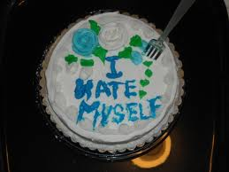

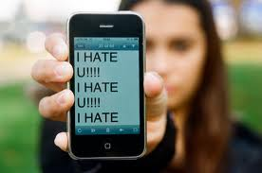   

**Bullies bully**

**on the internet.**

**Where?**

**Where do bullies bully?**

 

 

 

