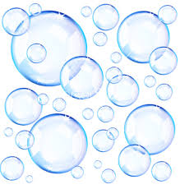

Bubbleology
The Science of Bubbles
Teacher John Strain

Challenge:
Learn English vocabulary to make a good solution for making bubbles. Learn about the characteristics of bubbles. Have fun making big bubbles and bubbles inside bubbles. Who can make the biggest bubble? How many bubbles inside bubbles can you make?

Materials (for a group of 5 students)
Data sheet 5 - Dish soap 120 mL - Distilled water 1000 mL - Glycerin 60 mL- Hand towels 1

Hoop for larger bubbles 5 - Rulers 5 - Tubs 1 - Spray bottles 1 - Straws 8

What to do?

Each student will:
- Spray the desk top with a mist of water.
- Dip the straw into the bubble solution and blow a bubble on the desk.
- When the bubble pops, measure the diameter of the ring left on the desk
- Record on your data sheet.
- Try again. What was the larger ring?
Round 2:
- Spray the desk top with a mist of water.
- Dip the straw into the bubble solution and blow a bubble on the desk.
- Dip the straw into the bubble solution and push the straw into the bubble and gently blow anther bubble.
- Repeat step 3 and see how many times you can do it. Count the bubbles inside your bubble.
- Record on your data sheet.
Round 2:
Bubble Mania – Go outside and make many bubbles both large and small

