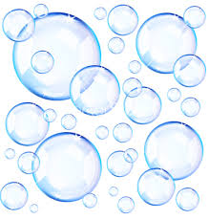

Bubbleology
The Science of Bubbles
Teacher John Strain

Teaching Plans: Bubbleology

Lesson 1:
- Discuss vocabulary
- Demonstrate touching a bubble with dry and wet finger
- Demonstrate spraying the desk top and blowing a bubble on the desk
- Demonstrate a bubble in a bubble
- Demonstrate a finger in a bubble.
- Demonstrate making a large bubble on the desk; measure it, record it
- Make sure the students record on their data sheet

Lesson 2:
- Review vocabulary
- Demonstrate making a bubble wand (Clothes hanger or aluminum wire)
- Have students make their wands
- Go outside and make bubbles

