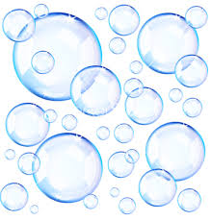

Bubbleology
The Science of Bubbles
Teacher John Strain

Try this at Home:
4 cups of water (1000 mL)
½ cup of dishwashing soap (120 mL)
4 table spoon of glycerin (60 mL)
Straw
Spray bottle of water
Data sheet

---------- ---------- ---------- ---------- ---------- ---------- ----------

Remember that bubbles like wet things and don’t like dry things.

---------- ---------- ---------- ---------- ---------- ---------- ----------

Mix the water, soap, and glycerin.

Blow a bubble with a straw.

Why do bubbles pop? Evaporation of touching dry surfaces

Pop a few bubbles with the dry end of the straw or your dry figure.

Bubbles won’t pop on wet surfaces.
Wet the straw and / or your finger and touch the bubble. It won’t pop!

Wet surfaces and glycerin slows down evaporation.

Spray a mist of water on a table. Blow a large bubble on the wet table. See how big you can make the bubble. Measure it. Record it on a data sheet.

Blow another large bubble on the wet table. Wet the straw in the bubble solution and poke the straw into the bubble on the table. Blow a bubble in the bubble. Repeat this and blow a bubble in a bubble in a bubble. How many can you do? Remember to wet the straw each time.

The bubble will pop when it touches something dry or the outside evaporates.

