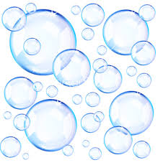

Bubbleology
The Science of Bubbles
Teacher John Strain

Data Sheet
Bubble Size |  |  | Bubbles Inside
Trial 1 |  |  | Trial 1
Trial 2 |  |  | Trial 2
Trial 3 |  |  | Trial 3

