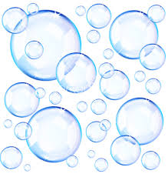

Bubbleology
The Science of Bubbles
Teacher John Strain

Vocabulary: | 詞彙： | Notes: 记录
Bubble | 泡沫
Shape | 形狀
Circle | 圈
Surface tension | 表面張力
inside | 內
Spray | 噴
Moist | 潮濕
Wet | 濕
Softly | 輕輕
Evaporation | 蒸發
Dry | 幹
Distilled water | 蒸餾水
Dish soap | 洗碗劑
Glycerin | 甘油
Tub | 桶
Straw | 稻草
Wand | 棍棒
Desk | 辦公桌
Data Sheet | 數據表
Spray bottle | 噴霧瓶

