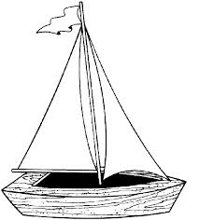
Float a Boat
Bouyancy
Teacher John strain

Challenge:
Learn English vocabulary to understand buoyancy. Then use your knowledge to build a tinfoil boat and test different designs to see how many coins you can load without sinking your boat.

Material:
Data Sheet - 30 cm ruler - Tin foil (20 cm x 20 cm) - Coins - Hand towels - Tub ½ full of water

What to do?

Each student will:
- Shape your tin foil to make a boat and draw your design on the data table.
- Predict how many coins your boat will hold. Write it on the data table.
- Float your boat. Put 1 coin at a time on your boat.
- Count how many coins you boat holds and record on your data table
Do not count the coin that sinks your boat.
Round 2:
Discuss with your team the boat designs. Make 1 more boat as a team to compete against other teams. Use your data table drawings to help you.

Round 3:
The teacher will float 2 boats of the same design in different tubs of water.
One tub will be tap water. The other tub will be filled with salt water.
Predict how many coins the boat will hold.
Predict how many coins can be held if the boat size was doubled.

Data Table

Draw Your boat  Label the:  Height, Length and Width | Predict how many coins your boat will hold. | Actual number of coins your boat held.
1. | 1.  _______ _______  _______ _______ | 1.  _______
2. | 2.  _______ _______  _______ _______ | 2.  _______
3. | 3.  _______ _______  _______ _______ | 3.  _______
4. | 4.  _______ _______  _______ _______ | 4.  _______
Team | Team | Team
 | _______ _______  _______ _______ | _______

